|  |
| --- |
| **Penugasan 1 – Laporan Aktifitas Memanfaatkan GIT** |

Ariel Febrio Hadi | 064002300013

Instalasi GIT terlebih dahulu, pilih Sistem Operasinya sesuai kebutuhan device masing-masing :

Device : macOs

Instalasi menggunakan **brew** di terminal, dan ketik **brew install git**

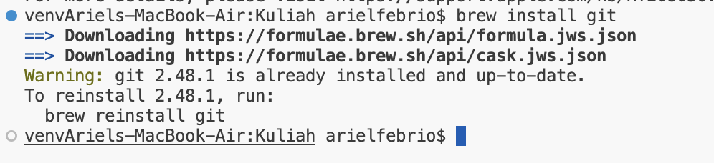

Jika sudah terinstall ganti terminal menjadi bash

Selanjutnya masuk ke direktori file yang telah terbuat





Mencoba melakukan command “git status”

Karena git status hanya bisa dijalankan dalam repository Git, dan git init diperlukan untuk membuat repository tersebut.







